UniHub
(MarunHub)

Software Requirements Specification

Date
28.03.2022

Group Members

- Ahmet Faruk Güzel 150119659
- Ahmet Aslan 150119902
- Hüseyin Kerem Mican 150119629
- Beşir Ezgin 150119780
- Muhammed Zahid Mansız 150119754

Prepared for
CSE3044 Software Engineering Term Project

Table of Contents

1. Introduction 3
1.1 Purpose 3
1.2 Scope 3
1.3 Definitions, Acronyms, and Abbreviations 3
1.4 References 3
1.5 Overview 3
2. General Description 4
2.1 Product Perspective 4
2.2 Product Functions 4
2.3 User Characteristics 4
2.4 General Constraints 5
2.5 Assumptions and Dependencies 5
3. Specific Requirements 5
3.1 External Interface Requirements 5
3.1.1 User Interfaces 5
3.1.2 Hardware Interfaces 5
3.1.3 Software Interfaces 5
3.1.4 Communications Interfaces 6
3.2 Functional Requirements 6
3.2.1 Request New Account or Login 6
3.2.1.1 Opening a new account (registering the application) 6
3.2.1.2 Account Confirmation by systems 6
3.2.1.3 Login 6
3.2.2 Request Quiz Competition 7
3.2.2.1 Select the desired lesson/topic for the quiz competition 7
3.2.2.2 Competition rules and informing the user 7
3.2.2.3 Process of answering questions 7
3.2.3 Request Chat 7
3.2.3.1 In terms of User, Chat 7
3.2.3.2 In terms of Admin, Chat 8
3.2.4 Request QR Attendance 8
3.2.4.1 Reading the QR code 8
3.2.4.2 Recording after the read QR code 8
3.3 Non-Functional Requirements 9
3.3.1 Performance 9
3.3.2 Reliability 9
3.3.3 Availability 9
3.3.4 Security 9
3.3.5 Maintainability 9
3.3.6 Portability 9
3.4 Inverse Requirements 10
3.5 Design Constraints 10
3.6 Logical Database Requirements 10
4. UML Diagrams 10
4.1 Use Cases 10
4.1.1 Use Case 1 10
4.2 Classes / Objects 11
4.3 Sequence Diagrams 12

1. Introduction

1.1 Purpose
The purpose of this document is to build a mobile application that contains three different sub applications. The main goal of this project is to provide convenience to students in their school life. This project has been produced with Attendance Taker, Quiz Game, Chat System to provide convenience for the target audience.
In many schools, new students' low affiliation with the school makes things difficult for the student. In the application, he can communicate with hundreds of students that he can message, take attendance with peace of mind, and test himself with a fun game after preparing for his exams.

1.2 Scope
UniHub is an application for university students that contains Attendance Taker, Quiz Game and Chat System. Firstly, students will login to the app with their student ID and password. After that process, they need to choose their active courses to register quiz system and join chat groups related to their active courses. This process will require a verification code to finish the registration, which will be send to their student, mail address. Afterwards, Attendance Taker is a QR Reader, which allows instructors to take attendance. Students will read the QR code that given by instructor via mobile app. Secondly, Quiz Game is a game platform, which helps students to prepare their exams. The platform has a question pool with related classes. The structure of quizzes based on multiple-choice questions. Lastly, Chat System is a system, which brings students together in a same chat room with related class. There will be chat room for every lecture separated from each other based on semester. After class registration date, the application will add students to chat rooms for each class. Therefore, students will have communication with each other easily without any extra effort.

1.3 Definitions, Acronyms, and Abbreviations
QR: Quick Response. In this project it will be used to take attendance.
GUI: Graphical user interface.
ID: Identifier. Will be used by users while logging in to the app.

1.4 References
- https://ieeexplore.ieee.org/abstract/document/6985772
- https://ieeexplore.ieee.org/document/951470
- https://ieeexplore.ieee.org/document/9347623

1.5 Overview
In the remaining part, there are some sections about the project. First section is about purpose and scope. In the second section, there are general descriptions about project, its functions. Through the third part there are detailed informations about the project such as its functional requirements, user interface etc.. Moreover there is a part that shows diagrams about project. These diagrams show how application will work, which parts will be activated and used.

2. General Description

2.1 Product Perspective
The project is a three-in-one application which allows university students to use utilizations that provide convenience. The system contains the following functions:
Quiz Game: It allows students to learn while having fun. It helps students to prepare for exams, with a pool of questions similar to the ones that came out already.
QR Attendance: This system saves time. It provides convenience to students and teachers.
Chat System: In chat system, all students taking the same courses will be able to communicate each other.

2.2 Product Functions
The project has many different functions to perform. Firstly there will be a login system to let the program to behave user specific. Because there are different lectures and there will be different quizzes, chat rooms and attendance according to the lecture.
Secondly, application has three different sections: Quiz Game, QR Attendance and Chat System. Quiz Game will have a question and 4 multiple choices shown to the user. When user selects the correct answer, the answer will be green and user will be able to move to the next question. When user selects a false option game will be over and user must start over to progress. Attendance will be taken by using QR. When user scans the QR code shown by the instructor, a page will be open and student will fill the necessary parts. In Chat part, user will select a lecture name to join its message group. User can send messages to other user through this system.

2.3 User Characteristics
Users of the system should be able to login properly. After the login process, user will be able to choose between three options. If the student wants to ask a question about the lecture, he/she will enter the chat system and send messages to other students. If student wants to prepare for the exam, he/she can take a quiz which is about the lecture. When a lecture starts, student will scan the shown QR code for attendance, easily. The system will support two types of user privileges, Student and Admin. Student can access to these three student functions, Admin will have access to the system such as Quiz Game and Chat System.

Start the Quiz Game:
- 10 questions will be shown.
- User will be able to choose between four options.
- There will be one correct and three false option for each question.
- If user chooses the wrong answer, the correct one will be shown.
- There will be a score system.
- Student can choose a specific lecture before entering the game.

Scan QR for attendance:
- Students will be able to scan the QR code which is shown by the teacher.
- In students’ mobile phone, after scanning the QR code, a page will open.
- Student should fill the necessary parts to show that he/she is attending the lecture.

Enter the chat system:
- After student enters to the chat system, they can send messages to other students.
- The chat system will have different lobbies.
- Every lobby will include students taking the course.
- User can send and receive messages through the system.

2.4 General Constraints
- To use data more efficiently we decided to use the global schema.
- We will use object oriented programing language for creating modular system.
- Flutter will be project’s main framework that we will develop

2.5 Assumptions and Dependencies
Let us assume that this is a proper student management system and it is used in the following application:
- In the quiz game when the system mix the question topic, the quiz game requirements will change from that time to end time.
- Operating system crash is the factor effecting the application requirement.

3. Specific Requirements

3.1 External Interface Requirements

User Interfaces
- Front-end software: Flutter UI
- Back-end software: Dart, MsSQL

Hardware Interfaces
- • Android Smartphone running Android OS version 4.0.3(API level 15)+
- • Android Smartphone running Android OS version 4.0.3(API level 15)+
- • Android Smartphone running Android OS version 4.0.3(API level 15)+
- • Android Smartphone running Android OS version 4.0.3(API level 15)+
- • Android Smartphone running Android OS version 4.0.3(API level 15)+
- • Android Smartphone running Android OS version 4.0.3(API level 15)+
- Android Smartphone and tablet running Android OS version 4.0.3(API level 15)+
- In addition, since the application works on the internet, the hardware (other than mobile internet) used to connect to the internet will be the hardware interfaces. Such as Modem, WAN-LAN.

3.1.3 Software Interfaces
- Following are the software used for the flight management online application.
SOFTWARE USED | DESCRIPTION
Operating system | Android in terms of cost-performance and because of the possibilities it offers in the development process.
Programing Language | We chose Dart to implement the project because it can be compiled quickly and is a native language.
Database | We chose MsSql to hold information that user information, questions for quiz competition etc.

3.1.4 Communications Interfaces
- The communication architecture must follow the client-server model.
- Communication between the client and server must be served over HTTP Secure (HTTPS).
- The client-server communication must be stateless.

3.2 Functional Requirements
This subsection contains the functional requirements for the UniHub. These requirements are organized by the features discussed in the proposal and literature survey document. These Features are then refined into use case diagrams and to sequence diagram to best capture the functional requirements of the system.

3.2.1 Request New Account or Login

3.2.1.1 Opening a new account (registering the application)
- The user has to register to the application and open an account in order to use the system.
- The user enters the email that registered in the school system and password.
- The system checks whether the entered email that registered with the school and the password.
- If the e-mail and password are correct, ok!
- However, if the e-mail is not a school e-mail or the password has not been determined by the user in accordance with the required standards, the system gives a warning to the user.
- This cycle continues until the user determines the correct mail and password according to the warning receives.
- At the end of, when the system receives the correct mail and the appropriate password, it creates an account for the user.

3.2.1.2 Account Confirmation by systems
- The user must verify the e-mail he entered into the system. This is very important for the security of the system.
- The system sends the code or link to the e-mail entered to complete the registration after the school e-mail and the password complying with the standards are entered.
- The user confirms the e-mail by entering the code sent by the system into the system or clicking the link.
- The system checks the entered code or link and completes the registration if the source is correct.

3.2.1.3 Login
- The user uses the e-mail and password registered in the system to log in to the application.
- The user enters the registered mail and password in the system.
- The system checks the user mail and password.
- If the password and e-mail are correct, the system logs the user in. If either or both of the password or e-mail is wrong, the system will warn the user.
- This cycle continues until the user enters the correct password and email.

3.2.2 Request Quiz Competition

3.2.2.1 Select the desired lesson/topic for the quiz competition
- Before starting the competition, the user must determine which content / from which course the questions will be.
- The system presents the user with a search box screen.
- The user enters the course name or subject content as keywords in the search box.
- The system presents all the contest options related to the keyword.
- The user chooses one of the options and the system directs the user to the competition.

3.2.2.2 Competition rules and informing the user
- Since the user is using the system for the first time, the system informs the user in terms of the competition rules (such as, the number of questions, etc.).
- Before the user sees the first question, the system gives information about the contest, such as the contest consists of 10 questions in total, 10 points for each correct answer, no right to pass, no transition between questions, the answer to each question will be notified immediately after answering the question (Correct-Green light, False-Red light) etc.
- The user informs the system to declare that has seen this information (pressing continue button)

3.2.2.3 Process of answering questions
- After the system starts the competition, the user continues until the last question by marking the option that thinks is correct for each question.
- After the system presents the first question to the user, the user marks the option they think is correct.
- After the user ticks the question, they move on to the next question (pressing next question button). This cycle continues until the last question.
- The user finishes the quiz after marking the last question (pressing end quiz button)
- The system notifies the user of the correct/incorrect answers and the competitor score.
- After the user notifies the system that has seen the results (pressing the OK button), the system offers the user the options to turn to the main page, new quiz.
- If the user selects the option to turn to the main page, the system sends the user to the main page, if selects the new quiz option, the situation is rewind.

3.2.3 Request Chat

3.2.3.1 In terms of User, Chat
- In the chat section, the user will be able to join the group of the course or subject he/she wants, share files in this group, and communicate with other members in the group.
- The user enters the keyword of the course or topic(course code etc.) they want to chat with in the search box provided by the system.
- The system presents all results for keywords as options the number of options varies by keyword).
- If no matching group is found in the search, the system informs the user and prompts the user to change the keyword.
- The user can choose any of the options and join the group he/she wants.
- Upon entering a chat group, general terms and conditions will be provided to user by the system.
- The user will be able to post a message and share a file with others group members.
- The user won’t be able to use web cam and private chat.
- The user will be able to leave a group.

3.2.3.2 In terms of Admin, Chat
- Unlike the user, the system gives the admin extra privileges to create new chat groups, manage existing groups, and maintain order in groups.
- Administrator will be able to create different chat groups according to different courses or general such as Database group, Networking group, Assignment group, Machine Learning group, AI group etc.
- Admin will be able to approve/reject requests to enter a group.
- Admin will be able to change some general rules and regulations for his/her group.
- Admin will be able delete a member from chat group.
- If a user does not follow the rules then admin will be able to mute this user.

3.2.4 Request QR Attendance

3.2.4.1 Reading the QR code
- The user should have the system read the unique QR code that the teacher reflects on the board in order to prove that he/she is in the classroom in the attendance of the course he/she entered.
- When the user requests QR scanning, the system requests permission to use the camera from the user.
- If the user does not give permission, the operation will fail and the system will notify the user.
- If the user allows, the system will present the QR reading screen to the user.
- The user sets the camera so that the QR code is inside the rectangle on the screen.
- The system reads the QR code if the user adjusts the camera angle correctly. If it cannot read, it informs the user (try again!). This cycle continues until the system reads the QR code.

3.2.4.2 Recording after the read QR code
- The system registers the user who read the QR code with the help of another system
- The scanned QR code sends the user to the attendance form created in google forms or to another link where polling can be taken.
- The user fills in the questions asked in the link they go to.
- In the system where the user is directed, only the academician or administrator can see and edit the recording results.

3.3 Non-Functional Requirements

3.3.1 Performance
- The product is web-based and must be run via a web server.
- The initial load time of the product depends on the internet connection strength of the environment in which the product is running. An average internet connection between 16 Mbps and 50 Mbps is ideal to wait for the standard operation of the system.
- We save 40% in Power usage because network searches are negligible, we don't do batch programming and we don't use very high power sources like GPS.
- In short, performance is based on the customer's hardware components.

3.3.2 Reliability
- The system will ensure that the databases, which make up 15% of all databases on average and must be protected, are stored off-site on redundant computers with automatic switching.
- The system takes advantage of the data protection APIs offered by the operating systems in order to provide the highest level of protection to the data.

3.3.3 Availability
- The system continues to facilitate interface designs and improve the result, as long as the mobile application usability scale survey does not yield 90% or more usable results.
- The system asks each user one time about application design and usage to measure usability.

3.3.4 Security
- The system logs out when the user is inactive for a certain period of time (average of 10-15 minutes) and at the request of the user.
- The system will not leave any data containing the password and e-mail on the mobile device where the application is located, if the User requests it.
- The user password can never be viewed by the operating system or other systems. It shall always be echoed with special characters representing typed characters.

3.3.5 Maintainability
- There are at least 4 maintenance processes per year, apart from what is needed for aspects such as application security and efficiency. In these processes, system downtime takes 10-15 minutes on average.
- In system updates (add new questions for quiz, etc.), the system interruption does not exceed 40 seconds.

3.3.6 Portability
- UniHub can be installed, deployed, accessed and managed in a portable way.
- Unihub can be downloaded from the Android Play Store.

3.4 Inverse Requirements
- The system is closed to academics. Therefore, in the system, there is no sharing by academicians about the courses.
- The chat section is not an environment for direct lessons like google classroom, but a platform that hosts everything from social life to education.

3.5 Design Constraints
- Unihub is the standard development tool to run in the Android environment.
- The system will be developed as open source application software.

3.6 Logical Database Requirements
- This section contains the logical requirements for information that is to be placed in a database.
- 90% of the data to be processed and stored is in alphanumeric/character data format.
- The system will ensure that the accuracy and consistency of the data is protected, secured, and by placing some restrictions on the database to ensure data integrity.

4. UML Diagrams

4.1 Use Cases

4.1.1 Use Case 1
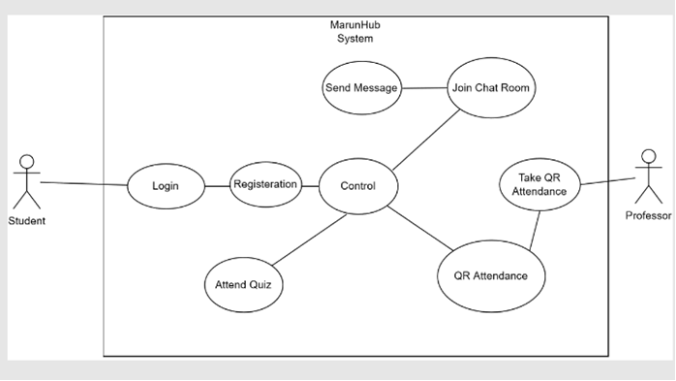

4.2 Classes / Objects
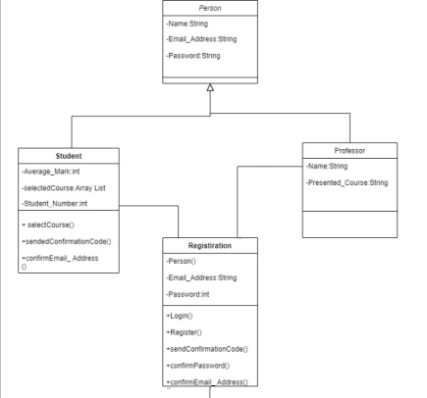

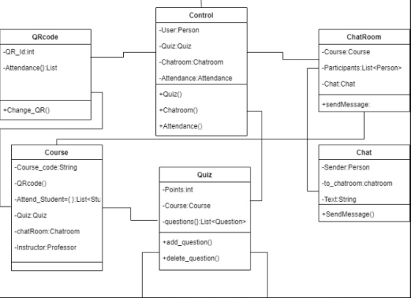

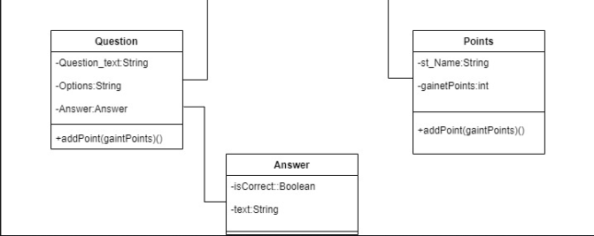

4.3 Sequence Diagrams

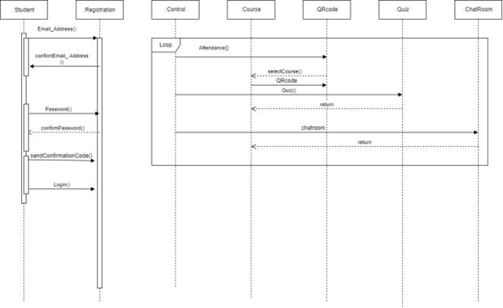

 | Part 1 | Part 2 | Part 3 | Part 4
Ahmet Faruk Güzel | 5 | 5 | 3 | 3
Ahmet Aslan | 3 | 4 | 5 | 4
Hüseyin Kerem Mican | 5 | 5 | 3 | 3
Beşir Ezgin | 3 | 3 | 3 | 5
Muhammed Zahid Mansız | 3 | 3 | 3 | 5

